The Mission of the Society of St. Vincent de Paul
Inspired by Gospel values, the Society of St. Vincent de Paul, a Catholic lay organization, leads women and men to join together to grow spiritually by offering person-to-person service to those who are needy and suffering in the tradition of its founder, Blessed Frédéric Ozanam, and patron, St. Vincent de Paul.
As a reflection of the whole family of God, members, who are known as Vincentians, are drawn from every ethnic and cultural background, age group, and economic level. Vincentians are united in an international society of charity by their spirit of poverty, humility and sharing, which is nourished by prayer and reflection, mutually supportive gatherings and adherence to a basic Rule.
Organized locally, Vincentians witness God's love by embracing all works of charity and justice. The Society collaborates with other people of good will in relieving need and addressing its causes, making no distinction in those served because, in them, Vincentians see the face of Christ.
“Amen, I say to you,
whatever you did for one of these least brothers of mine,
you did for me.”

Matthew 25:40

Your financial donation provides direct help to the poor in the local community.

Through your generosity, you help people struggling to survive.

Donations are 501 (c)(3) tax deductible:

Society of St. Vincent de Paul
Thief River Falls Conference
c/o St. Bernard’s Catholic Community
105 Knight Avenue North
Thief River Falls, MN 56701

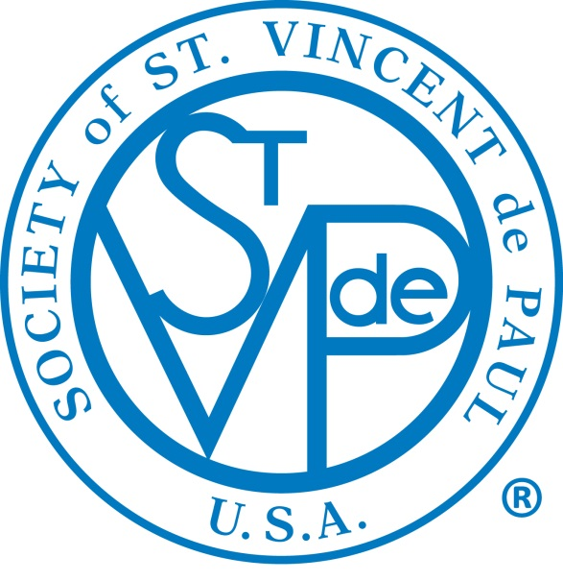

Society of St. Vincent de Paul
Thief River Falls Conference
218-681-3571 ext. 212

As one of the oldest charitable organizations in the world, the Society of St. Vincent de Paul (SVdP) is a Catholic lay organization of about 800,000 men and women throughout the world who voluntarily join together to grow spiritually and offer person-to person service to the needy and suffering in 150 countries on five continents.

- We serve Thief River Falls and the surrounding area.

- We volunteer to serve those in need and bring them closer to God.

- We seek to understand needs of you or your family.

- We offer presence and compassion, information and self-help.

- We help prioritize needs and discuss other available resources. We may offer limited financial assistance.

- We maintain confidentiality.

- Phone 218-681-3571 ext. 212
If no answer, please leave a message and your call will be returned as soon as possible.

- After the initial phone interview, we will set up an appointment for a home visit or meet at a public location,
i.e. church.

- After the person-to-person visit, two volunteers will determine the best way to provide assistance to you based on your situation.

- Why? Because we care about you.

